

Programming Fundamentals
(CIT1124)

ASSIGNMENT

Name: Chew Jie Weei
Lecturer: Mr Ariff
Table of Contents
1.0 Introduction 3
2.0 Analysis 4
3.0 Design 6
3.1 Program Steps 6
3.2 Pseudocode 6
3.2.1Program Pseudocode 6
3.3 Flowchart 8
4.0 Testing 9
5.0 Source Code 10
6.0 Conclusion 13
7.0 Reference 14

1.0 Introduction
There is a company called Company XYZ and it has ten employees who earn commissions based on their monthly sales performance. This project aims to develop a C++ program that calculates the commission for each employee according to predefined commission rates. The program is designed to efficiently store sales data, perform the necessary calculations and display the results for all employees in a clear and organized format. The advantage of using code to calculate each employee's salary is that it not only saves time from manual calculations, but also reduces various errors caused by manual calculations and avoids misunderstandings. In this report also shown the code, what are the concepts of the coding part and how to calculate the commission.

2.0 Analysis
The main objective of this program is to develop a system that can accurately calculate and display the commission for each employee based on their monthly sales in Company XYZ. Each employee earns a commission based on their monthly sales according to predefined commission rates. The following describes how the commissions for each employee and the calculated commission is based on the formula:
Commission = Sales * Commission Rate
Monthly Sales | Commission
Greater than or equal to $50,000 | 16% of sales
Less than $50,000 but greater than or equal to $40,000 | 12% of sales
Less than $40,000 but greater than or equal to $30,000 | 10% of sales
Less than $30,000 but greater than or equal to $10,000 | 6% of sales
Less than $10,000 | 3% of sales

Once we know how all employees’ commission is calculated, we can enter each employee’s sales figures and multiply them by a predetermined percentage to receive their due commission. The first function is to obtain input for the monthly sales for all ten employees. Then the second function is using the prepared code to calculate the commissions for these ten employees. Both functions require storing the data in the array. Then the third function is used to display all the information stored in these two arrays.

The question also has shown the input and the output reference:
Input:
Enter Monthly Sales:
Employee1: 10000
Employee2: 25000
Employee3: 30000
Employee4: 60000
Employee5: 40000
Employee6: 500
Employee7: 80000
Employee8: 1000
Employee9: 2000
Employee10: 5000

Output:
Results of Calculations
----------------------------------------
Employee Sales Commission
----------------------------------------
Employee 1 10000 600
Employee 2 25000 1500
Employee 3 30000 3000
Employee 4 60000 9600
Employee 5 40000 4800
Employee 6 500 15
Employee 7 80000 12800
Employee 8 1000 30
Employee 9 2000 60
Employee 10 5000 150

The output of the program displays each employee’s sales and the corresponding commission in a structured format. This allows users to clearly view and verify the results. The main objective of this program is to automate the calculation process to reduce human error and improving efficiency compared to manual calculations. It is assumed that all input values entered by the user are valid numeric values and that sales figures are non-negative. The program does not handle invalid or unexpected input. Overall, this program provides a simple and efficient solution for calculating and displaying employee commissions.

3.0 Design

3.1 Program Steps
The design of this program is divided into several steps. The first steps is that the program will require the user to input the employee’s monthly sales. These values will be stored in an array for further processing. Next, the program processes the sales data by applying conditional statements to determine the correct commission rate for each employee. Then the commission is calculated using the formula: Commission= Sales * Commission Rate. After finishing the calculate, the results will be stored in a second array. Lastly, the program displays the sales and commission for all employees in a structured format. This program is using a Loop function to ensure that all ten employees’ data are displayed.

3.2 Pseudocode
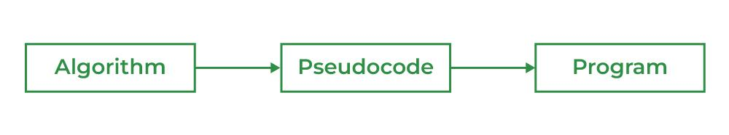

Pseudocode(What Is PseudoCode, 09:59:13+00:00) is a step-by-step description of an algorithm written in simple English using a code-like structure. It is designed for human understanding, not for machine execution and does not follow the syntax of any programming language. We need Pseudocode to help programmers to plan the solution before writing an actual code. Pseudocode also will make the logic easy to understand for others reading the solution. It also will bridge the gap between algorithms design and coding. Last, it also will reduce the logical errors before implementation.

3.2.1Program Pseudocode
START
DECLARE sales [10]
DECLARE commission [10]

FOR i =0 TO 9
INPUT sales [i]
END FOR

FOR i =0 TO 9
IF sales [i] >=50000
commission [i] =sales [i] * 0.16
ELSE IF sales [i] >=40000
commission [i] =sales [i] * 0.12
ELSE IF sales [i] >=30000
commission [i] =sales [i] * 0.10
ELSE IF sales [i] >=10000
commission [i] =sales [i] * 0.06
ELSE
commission [i] =sales [i] * 0.03
END FOR

FOR i =0 TO 9
DISPLAY sales [i], commission [i]
END FOR

END

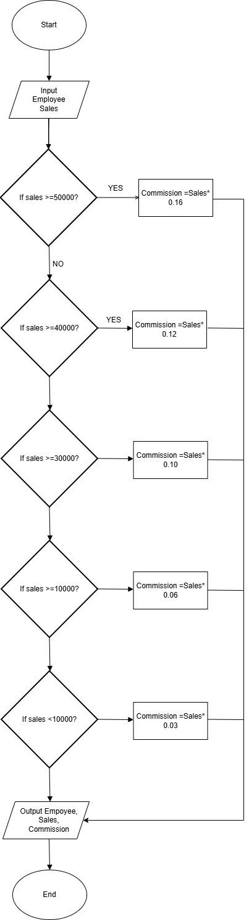
3.3 Flowchart
Figure 1: Flowchart for The Program

4.0 Testing
Test ID | Description | Expected Results | Actual Results
T1 | Test Low Value - $500 | $500 * 3%=15 | $15
T2 | Test Low Value - $700 | $700 * 3%=21 | $21
T3 | Test Low Value - $900 | $900 * 3%=27 | $27
T4 | Test Less Than $10000 - $2500 | $2500 * 3%=75 | $75
T5 | Test Less Than $10000 - $5000 | $5000 * 3%=150 | $150
T6 | Test Less Than $10000 - $7500 | $7500 * 3%=225 | $225
T7 | Between $10000 and $30000 -$10000 | $10000 * 6%=600 | $600
T8 | Between $10000 and $30000 -$15000 | $15000 * 6%=900 | $900
T9 | Between $10000 and $30000 -$25000 | $25000 * 6%=1500 | $1500
T10 | Boundary Test at $30000 | $30000 * 10%=3000 | $3000
T11 | Boundary Test at $40000 | $40000 * 12%=4800 | $4800
T12 | Boundary Test at $50000 | $50000 * 16%=8000 | $8000
T13 | Test High Value - $80000 | $80000 * 16%=12800 | $12800
T14 | Test High Value - $90000 | $90000 * 16%=14400 | $14400
T15 | Test High Value - $100000 | $100000 * 16%=16000 | $16000
T16 | Just Below 10000 - $9999 | $9999 * 3%=299.97 | $299.97
T17 | Just Below 30000 - $29999 | $29999 * 6%=1799.94 | $1799.94
T18 | Just Below 40000 - $39999 | $39999 * 10%=3999.90 | $3999.90
T19 | Just Below 50000 - $49999 | $49999 * 12%=5999.88 | $5999.88
T20 | Zero Value Test - $0 | $0 * 3%=0 | $0

In this test, we used various data sets to ensure the accuracy and reliability of the program and to avoid any errors. First, the test included low-value tests (like $500, $700 and $900) to verify that the program can correctly applied the 3% commission rate. Second, it included tests using a normal range (like $10000 to $25000) to ensure the correct commission rate was applied across different sales ranges. Third, the test also included boundary tests with the critical values required by the question (like $10000, $30000, $40000 and $50000) to confirm that the program could correctly handle boundary situations where the commission rate changed. Additionally, values slightly below the boundary (like $9999, $29999, $39999 and $49999) were also included to verify that the program would not incorrectly apply the same commission rate. Next, high-value testing (like $80000, $90000 and $100000) is also a part of the testing process. This is to ensure the program functions correctly even with large input values. Finally, zero-value data (like 0 dollars) is also tested to ensure the program functions correctly even under illogical conditions. In summary, these test cases ensure coverage of all possible situations and scenarios and that the program produces accurate results under different input values.

5.0 Source Code
#include <iostream>
#include <iomanip>
using namespace std;

void MonthlySales (double sales [])
{
for (int i =0; i <10; i++)
{
cout << "Employee" << i+1 << ":";
cin >> sales [i];
}
}

void CalculateCommission (double sales [], double commission [])
{
for (int i =0; i <10; i++)
{
if ( sales [i] >=50000)
commission [i] =sales[i] * 0.16;
else if ( sales [i] >=40000)
commission [i] =sales[i] * 0.12;
else if ( sales [i] >=30000)
commission [i] =sales[i] * 0.10;
else if ( sales [i] >=10000)
commission [i] =sales[i] * 0.06;
else
commission [i] =sales[i] * 0.03;
}
}

void ResultCalculate (double sales [], double commission [])
{
cout <<"Results of calculations" << endl;
cout << "----------------------------------------\n" << endl;

cout << setw(10) <<"Employee";
cout << setw(13) <<"Sales";
cout << setw (16) <<"Commission" <<endl;
cout << "-----------------------------------------\n";
cout << fixed << setprecision (2);

for (int i=0;i<10;i++)

{
cout << setw(12) <<"Employee" << i+1
<< setw(13) <<sales [i]
<< setw(13) <<commission [i] << endl;
}
}

int main()
{
double sales[10];
double commission [10];

cout <<"Enter monthly sales:\n";
MonthlySales (sales);
CalculateCommission (sales, commission);
ResultCalculate (sales, commission);

system ("pause");
return 0;
}

6.0 Conclusion
In summary, the program developed in this project successfully achieved the goal of calculating and displaying commissions based on employees' monthly sales. By implementing conditional logic, the program can correctly allocate commission rates according to different sales ranges.

The use of arrays enables efficient data storage, while loops allow for repeated processing of multiple employees. Furthermore, the modular design utilizes functions to improve code organization and maintainability.

This program has undergone comprehensive testing, covering boundary values, normal ranges, and extreme cases. Test results confirm that the program runs accurately and stably under all test conditions.

This project not only demonstrates the application of basic programming concepts but also emphasizes the importance of logical thinking and structured design in software development. Future improvements may include beautifying the system and expanding it to handle more employees.

7.0 Reference
- What is PseudoCode. (09:59:13+00:00). GeeksforGeeks. https://www.geeksforgeeks.org/dsa/what-is-pseudocode-a-complete-tutorial/

